- True or False: the async…await syntax has functionality that cannot be accomplished by native promises.
- False
- True
- What purpose does the async keyword serve?
- It`s an operator that halts the execution of a function until a promise is no longer pending.
- It`s a function that returns a function and/or accepts a function as a parameter.
- It`s a built –in function which a callback function and number of milliseconds as parameters and delays the execution of the callback function that number of milliseconds.
- It`s keyword which indicates an asynchronous function.
- Which of the following is useful for awaiting multiple promises where all are required but none depend on each other to execute?
- Promise.all()
- Using nested callback function.
- setTimeout()
- Using the async…await syntax instead of native promise syntax.
- What does the function example() return?
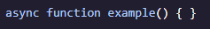
- A string
- undefined
- A promise
- A function
- What purpose does the await keyword serve?
- It`s a function passed into another function as a parameter which is invoked during of that function.
- It`s an operator used only inside an async function that halts the execution of a function until a given promise is no longer pending and returns the resolved value of the promise.
- It`s a keyword which indicates an asynchronous function.
- It`s a JavaScript object which represents the eventual outcome of an asynchronous operation

- What will this code print to the console ?
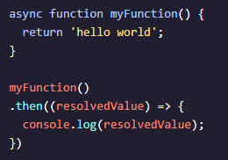
- Promise { <pending> }
- hello world
- it won`t print anything.
- Promise { ‘hello world’}
- Given that firstPromise(), secondPromise(), and thirdPromise() do not depend on each other to execute, what isn`t ideal about the provided code?
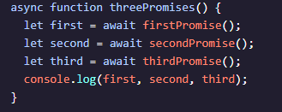
- Using await halts the execution of the function which means consecutive promises would wait to execute until the previous promise resolved. Instead, we should allow for concurrency whenever possible.
- The promises are not resolved when logged to the console.
- The async and await keywords should be switched.
- An async function can only have one await per function.
- Which of the following is NOT a benefit of the async…await syntax?
- It cause promises to resolve faster.
- It lets us easily store and refer back to the resolved values of earlier promises in a promise chain.
- It reads more similarly to synchronous code.
- It lets us catch rejected promise errors with the exact same we use to catch other types of errors.

